<https://www.google.com/url?sa=i&url=https%3A%2F%2Fwww.printables.com%2Fmodel%2F55508-wera-precision-screwdriver-holder&psig=AOvVaw3o0wAHrmC5TcHnB7W2Xp2N&ust=1735237690337000&source=images&cd=vfe&opi=89978449&ved=2ahUKEwj5kauixsOKAxWyMXkGHc5mHocQjB16BAgAEAg>

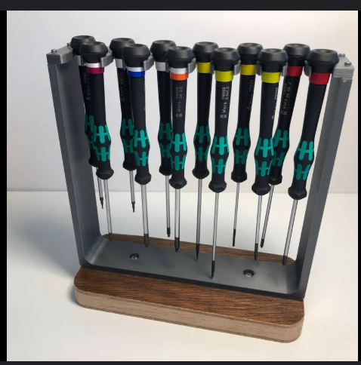

<https://www.google.com/url?sa=i&url=https%3A%2F%2Fwww.thingiverse.com%2Fthing%3A2918462%2Fcomments&psig=AOvVaw01Fj70pOwK-lllnEBpG27a&ust=1735241754652000&source=images&cd=vfe&opi=89978449&ved=2ahUKEwjsoa201cOKAxVVMHkGHSpNKScQjB16BAgAEAg>

